**Purpose:**

The primary purpose of this lab is to tie together previously learned CCNA concepts such as IPv4 subnetting, IPv6 subnetting, and core OSPF concepts (single and multi-area) in one lab to provide a thorough refresher. Furthermore, this lab serves as an introduction to setting up lab environments without any given outlines, to test skills of designing and creating networks independently, a skill that is needed as a good network engineer.

**Background Information:**

OSPF is a network routing protocol that allows the various routers in a large network to easily exchange information amongst each other. OSPF is primarily used to distribute the shortest route that it takes to get to each router in a network. Routes can be thought of as physical directions to another router. Analogous to how a person would use a map to navigate to a destination, routers use distributed OSPF route information to know where to send their information based on a destination. More specifically, OSPF uses the SPF (Shortest Path First/Dijkstra) algorithm to calculate these routes, which are then distributed amongst every router in the network. Before all these routes can be distributed however, each router on the network must run an OSPF process. Furthermore, routers must have established OSPF neighbors. Two routers are considered neighbors when

https://www.cisco.com/c/en/us/support/docs/ip/open-shortest-path-first-ospf/13703-8.html

**Lab Summary:**

**Lab Commands:**

ip ospf PROCESS_ID area AREA_ID

network command

ipv6 unicast-routing

router ospf PROCESS_ID

**Network Diagram:**

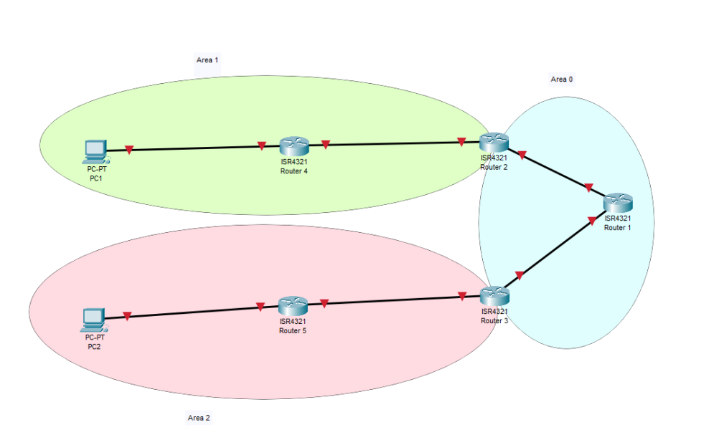

**Configurations:**

**Problems:**

**Conclusion:**

General Lab Report Guidelines for CCNP and CCSP classes

In your lab write-up I want 9 categories titled:

**Purpose**

**Background Information on lab concepts**

**Lab Summary**

**Lab Commands**

**Network Diagram with IP’s**

**Configurations** Show run on all routers involved

Show IP route on all routers

**Problems**

**Conclusion**

**Teacher Signoff Page of Lab Completed**

The purpose should be a short paragraph covering the major purpose of the lab. What concepts am I trying to teach by having you do this lab?

Background information should be an explanation of major concepts covered in the lab. This should be written such that those without a CCNP background can understand what the main concepts were. ***Your target audience is Human Resource people not IT people.*** Be detailed and cover the critical concepts of the lab.

Lab Summary should be a written summary of what you actually setup and accomplished as it specifically relates to this lab.

Lab Commands is a specific section that talks about all the new commands required to do this lab. Talk about the commands and what each option does. It can be integrated in the other sections but I need specifics on the particular commands.

Network Diagram must be a digital (not handwritten) diagram or graphic of what you setup. It should exactly match the details of what was written in the lab summary. You can use tools such as packetracer, visio, gimp, etc… Ideally, it should be large enough to easily see what the lab configuration is of your routers, ip’s, and interfaces. Do not double space your router configs. These items are bare minimum. Feel free to add to this anything that can more easily convey the setup of your lab. For example, things you may also want to include would be routing protocols and area id’s.

Configurations—the minimum I am looking for here is a printout of show run and show IP route on all your routers. Feel free to add other details that can help your lab.

The problem section is actually one of the most important parts of this lab. I want to hear what issues you had in the lab and what you did to solve them. What was particularly challenging? Tell me specifically what you personally learned in this lab. You should be taking a log daily and incorporating it into this problem section.

The conclusion section is the standard wrap-up of the lab. A brief description, what you did, what went wrong or well and what you learned.

If you have any questions on how this relates to a particular lab, please ask